APPS For Business Travellers
Technology varies day to day.One should change according to the new technology and trends.Getting to update with the trends is very important.The most common using technology is APPS.for a business man it is very important to know different APPS. for the business traveler it is very important to know different apps and application.The most trending apps 2018 is listed below
UBER EATS :
It is one of the most trending app using now a days.with the help of uber eats we can sort out the best restaurant near by.Reviews and menus are available.The app provides convienent ordering by clicking one button

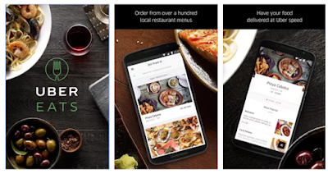

PACK POINT :
Last minute business trips can be stress ful.but with the help of pack point we can stay updated
its completely free of cost.we can some additional extra feautres if it necessary.it will remind us to stay updated
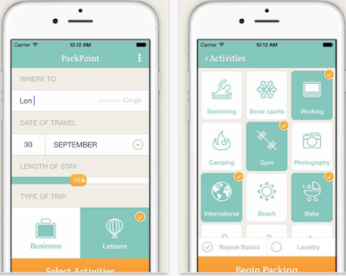
HAPPY COW :
finding a restaurant that is vegetarian and vegan friendly is really a difficult task .especially if you are in unfamiliar place.Happy cow is the best thing for all vegans and for healthy food.It is located for about 180 countries .Travelers with dietary requirements can use this app .Its completely free of cost

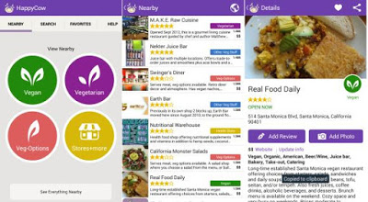
LOUNGE BUDDY :
Enjoy the comfort and luxury of lounge access in between flights.no matter,your cabin class.Lounge buddy is portable lounge directory for airports all over the world.find out which lounge is better and you can book your pass directly from app.you can also buy gift vouchers from your friends.its free of cost and travelers with out lounge aces can use this
